ĐỀ CHÍNH THỨC  (Đề thi có 08 trang) | KỲ THI CHỌN HỌC SINH GIỎI LỚP 6 CẤP HUYỆN  MÔN THI: TIẾNG ANH (HỆ 10 NĂM)  Thời gian làm bài 120 phút, không kể thời gian giao đề.
Điểm | Họ tên, chữ kí giám khảo | Số phách
Bằng số: ……………………..… | 1……………………………….
Bằng chữ: ……………………… | 2……………………………….
Chú ý: - Thí sinh làm bài trực tiếp vào đề thi.
- Thí sinh không được sử dụng bất cứ tài liệu gì kể cả từ điển.
SECTION 1: LISTENING.
Part I. Listen and tick the box. Then write A,B,C or D in the box below (5 points)
1.Where does her brother work?
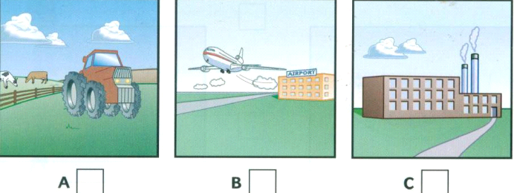

2. How does he go to work?
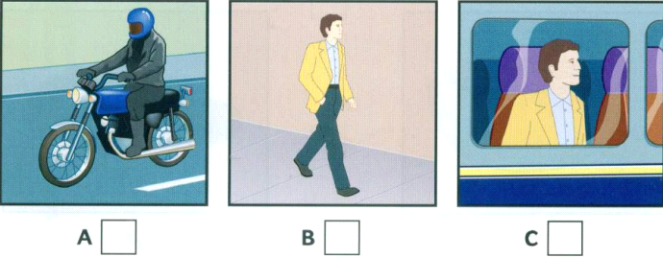
3. When does he start work?

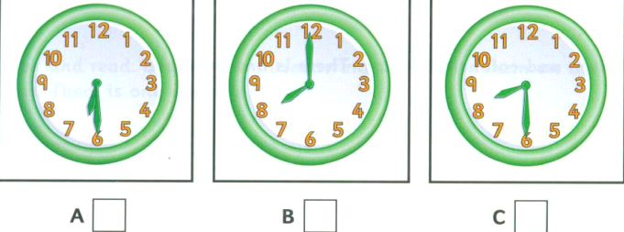
4. What does he do for lunch ?

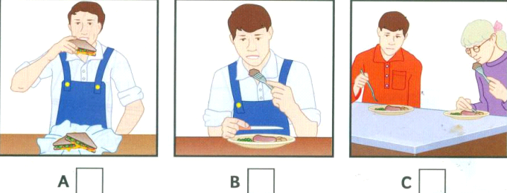
5. What did he do before he started this job?

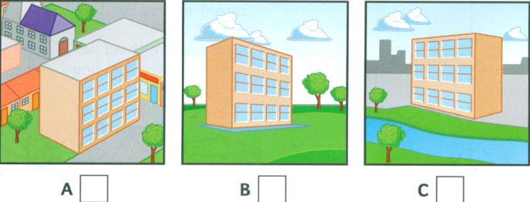
Write your answer here
1 __________ | 2___________ | 3___________ | 4 ___________

Part II. Listen and write ( 10 points)
New Street school library
0. Full name: Sarah Tanner
1. Age : ………………………………
2. Teacher’s name : ………………………………
3. Favourite books: ………………………………
4. Hobbies: ………………………………
5. How many books: ………………………………
Write your answer here
1 __________ | 2___________ | 3___________ | 4 ___________

Part III. Listen and write the answer to correct heading. What did Ben do last week ? (5 points )

0. Monday | 0. B | A. He bought a book in the village shop and sat on the sand and read it
1. Wednesday | 1. _____ | B. He went to kind of museum and saw lots of different fish.
2. Saturday | 2. _____ | C. He went to the beach and climbed up to the top of a big rock
3. Tuesday | 3. _____ | D. He went for a walk in the village , ice creams
4. Friday | 4. _____ | E. He went fishing in boat
5. Sunday | 5. _____ | F. He saw a film about a woman climber
Write your answer here
1 __________ | 2___________ | 3___________ | 4 ___________

SECTION 2: PHONETICS.
III. Choose the word whose underlined part is pronounced differently from the rest by circling the corresponding letter A, B, C or D. (10 points)
1.A. though B. thank C. throw D. thin
2. A. how B. rose C. know D. remote
3. A. sofa B. summer C. sugar D. sound
4. A. travelled B. started C. decided D. visited
5. A. dear B. wear C. nearby D. appear
Write your answer here
1 __________ | 2___________ | 3___________ | 4 _________ | 5 _________

IV. Choose the word with different stress pattern. Write A, B, C or D in the space provided (10points)
1. A. adventure B. appliance C. automatic D. activity
2. A. pollution B. television C. vacation D. attention
3. A. popular B. interesting C. difficult D. important
4. A. character B. entertain C. documentary D. afternoon
5. A. restaurant B. fantastic C. factory D. beautiful
1 __________ | 2___________ | 3___________ | 4 _________ | 5 _________
SECTION 3: VOCABULARY & GRAMMAR.
V. Choose the best answer to complete each sentence, identify your answer by circling the corresponding letter A, B, C, or D. )(50 points)
1. Would you like to play tennis, Nam?
A. I’d like to, but I can’t B. Yes, I’d like to C. No, thanks D. I’d like to go
2. That’s a…………….. building.
A. five- floor B. five- floors C. five- floor’s D. five- floors’
3. My parents make me……………..for my exam.
A. to study B. study C. studying D. studied
4. Can I borrow your fishing rob, Minh?
A. No, I can’t B. I’m sorry Nam I’m using C. I’d love to D. Yes, please
5. Traffic police never let you……………..without a ticket
A. go B. going C. to go D. gone
6. London is ……………..of England.
A. capital B. the capital C. a capital D. one capital
7. ________ do you go shopping? – Every week.
A. How far B. What time C. How often D. How
8. The opposite of “dangerous” is . . . . .
A. polluted B. safe C. good D. dirty
9. ________ was in. The room was empty.
A. Anybody B. Somebody C. Everybody D. Nobody
10. How ........................... homework does Lan have every day?
A. much B. many C. old D. often
11. Tom hates watching T.V. ……………..does Peter.
A. So B. Too C. Neither D. Either
12. Hoa prefers colorful dances in Thailand…………….. shadow puppet shows in Indonesia.
A. to B. than C. as D. for
13. Helen is my aunt’s daughter so she is my________.
A. sister B. cousin C. niece D. friend
14. Millions of children around the world enjoy the cartoon because it can both ………………..and …………………..a young audience.
A. entertain- education B.entertainment- education
C.entertainment- educate D. entertain – educate
15. Uncle Ho was born……………...
A. At 1890, in May B. on May, 1890 C. 1890, at May D. in May,1890
16. I drink ………….coffee than you.
A. little B. less C. few D. fewer
17. If we …………………cutting down trees, we can’t prevent floods and other natural disasters
A. will stop B. don’t stop C. stop D. won’t stop
18.A: Would you like a glass of lemon juice? – B: ……………... I’m very thirsty
A. No, I’m not B. Yes, please C. No, thanks D. Yes, I do.
19. ……………..?” - “That’s a great idea.”
A. Do you like playing sports B. Can you buy me some apples
C. Why don’t we go out for dinner D. May I borrow your pen
20. When . . . . . to San Francisco? - In 2010
A. have you gone B. did you go C. do you go D. will you go
21. - A: “I’ve just received a scholarship.” - B: ……………..
A. Really B. Thank you C. Congratulations D. Well
22. That is . . . . . book I’ve ever read.
A. the borest B. the boring C. the most bored D. the most boring
23. It’s getting light. Shall I turn . . . . . the lights to save electricity?
A. off B. up C. on D. in
24. In the future, robots will help us to surf the . . . . .
A. websites B. Internet C. channels D. TV programmes
25. What does 3Rs stand . . . . . ?. It’s Reduce, Reuse, Recycle.
A. at B. for C. on D. By
Write your answer here

1 __________ | 2___________ | 3___________ | 4 _________ | 5 _________
6 __________ | 7___________ | 8___________ | 9_________ | 10_________
11 __________ | 12__________ | 13___________ | 14_________ | 15_________
16 __________ | 17__________ | 18___________ | 19_________ | 20_________
21 __________ | 22__________ | 24___________ | 24_________ | 25_________

VI. Supply the correct tense or form of the verbs in brackets. (20 points)
1 you (watch) the tennis match on TV last night?
- If the weather is good, the plane (leave) on time.
- My brother (not/listen) to rock music. He hates it.
- If you want to lose weight, you should (do) some exercise.
- They (learn) English since last year.
Write your answer here

1 __________ | 2___________ | 3___________ | 4 _________ | 5 _________

VII. Give the correct form of the words in capital to complete the sentences. (1.0 point)
1. Her birthday is on the……….…of September. TWENTY
2. There are five… ….……in the kitchen. KNIFE
3. There are a lot of interesting… ….……in the summer. ACT
4. It was the bird’s first …………………. from the nest. FLY
5. Yesterday we spent a ………………. afternoon by the river. PEACE
6. They often play sports. They are very……. …… SPORT
7. She’s a good student but she lacks …………………… . CONFIDENT
8. Stephen Biko was an ………………..……supporter of the peace movement. ENERGY
9. In my… …….…, there is a market, a clinic, a post office and a supermarket NEIGHBOR
10. Air……. ……is a big problem in the big cities. POLLUTE
Write your answer here
1 __________ | 2___________ | 3___________ | 4 _________ | 5 _________
6 __________ | 7___________ | 8___________ | 9_________ | 10_________

VIII. Circle the letter A,B,C or D before the mistake in each sentence. (1.0 point)
1. There are much music programmes on TV nowadays.
2. Her father often listens to radio in the morning.
3. She is the most beautiful of the twin sisters.
4. This is my book and that is your.
5. The Discovery Channel makes education funny for children all over the world.
Write your answers here

 | 1 | 2 | 3 | 4 | 5
Mistake | ……………. | …………… | …………… | …………… | ……………
Correction | …………… | …………… | ………… | …………… | ……………

SECTION 4: READING.

IX. Read the passage. Then choose one suitable word to fill in the gaps. (20 points)
(1)_________the United States, many adults and children (2)_________overweight. Some people eat (3)_________food at meals. They also eat snacks between meals. Sometimes people eat healthy snacks like fruit or vegetables (4)_________many Americans eat a lot of junk food such as cookies, candy and potato chips. Eating junk food can (5)_________people gain weight. People also gain weight (6)_________they don’t get enough (7)_________. People need to walk, run, ride bicycles, or walk out in health clubs and gyms .When people exercise, they (8)_________good and have more energy. A good diet and exercise will help you (9)_________a long and (10)_________life.
1. A. on B. In C. At D. from
2. A. is B. was C. were D. are
3. A. too many B. too much C. few D. plenty
4. A. but B. because C. although D. so that
5. A. get B. lead C. urge D. make
6. A. so B. however C. but D. because
7. A. exercises B. work C. money D. energy
8. A. become B. taste C. have D. feel
9. A. live B. lives C. living D. to living
10. A. health B. safe C. fair D. healthy

Write your answer here
1 __________ | 2___________ | 3___________ | 4 _________ | 5 _________
6 __________ | 7___________ | 8___________ | 9_________ | 10_________

X. Fill in each blank with ONE suitable word. (20 points)
Lan was right – Hoa soon got used (1) ________the busy city traffic. She could cross the road and she wasn’t scared. Then her uncle bought her a bike. (2) ________began to go out more often in the evening. Usually, she visited her (3) ________. They talked and listened to music or helped each other (4) ________their homework.
Hoa rarely went to see movies or ate out (5) ________the evening. Everything was far too expensive. She preferred to socialize (6) ________her friends. She enjoyed it and it cost nothing.
Then one day, Lan (7) ________Hoa went to the public library. Hoa liked to read. There wasn’t a library in her village, so she couldn’t (8) ________many books. The public library in the city had thousands of (9) ________, and Hoa began to borrow books regularly. She decided that (10) ________city wasn’t so bad after all.
Write your answer here

1 __________ | 2___________ | 3___________ | 4 _________ | 5 _________
6 __________ | 7___________ | 8___________ | 9_________ | 10_________

XI. Read the following passage, then answer the questions by circling A, B, C or D. (10 pts)

Bobbi Brown is a very busy man. He is 60 years old and he has thirteen jobs. He is a postman, a policeman, a fireman, a taxi driver, a school bus driver, a boatman, an ambulance man, an accountant, a petrol attendant, a barman and an undertaker. Also, he and his wife, Margaret, have a shop and a small hotel.
Bobbi lives and works on the island of Gigha in the west of Scotland. Only one hundred and twenty people live on Gigha but in summer this number will be doubled because of tourists who come by boat every day.
Every day Bobbi gets up at 6.00 and makes breakfast for the hotel guests. At 8.00 he drives the island’s children to school. At 9.00 he collects the post from the boat and delivers it to all the houses on the island. He also delivers the beer to the island’s only pub. Then he helps Margaret in the shop.
He says: “Margaret likes being busy, too. We never have holidays and we don’t like watching television. In the evenings Margaret makes supper and I do the accounts. At 10.00 we have a glass of wine and then we go to bed. Perhaps our life isn’t very exciting, but we like it”.
1. Bobbi Brown is a very busy man because____________.
A. he is 60 years old B. he has thirteen jobs
C. he lives and works on the island D. he is a postman
2. In summer, about ____________tourists come by boat every day.
A. 120 B. 60 C. 240 D. 150
3. He usually takes the island’s children to school by ____________.
A. bus B. taxi C. boat D. ambulance
4. What does Bobbi do in the evenings? ~ ____________.
A. He makes supper B. He watches television
C. He goes to bed early D. He does the accounts
5. They don’t watch television in the evenings because ____________.
A. They have a glass of wine B. They never have holidays
C. They don’t like it D. They are always tired in the evening
Write your answer here

1. | 2. | 3. | 4. | 5.

SECTION 5: WRITING
XII. Rewrite each of the following sentences in such a way that it means the same as the first one. (20 points)

1. I won’t be able to do anything unless I have a quiet room.
=> If I don’t have
- Minh likes teaching robots very much.
=> Minh is very interested in
- The students started to collect old clothes for their charity programme last week.
=>The students have
- We will probably go to the moon for our summer holiday in 2050.
=>We might
- Nobody in our class is as intelligent as Hoa
=>Hoa is
- Living in the city is more expensive than living in the countryside.
=>Living in the countryside
- There are many interesting films on VTV3 today.
=>Today VTV 3 has
- My brother plays football very well.
=>Minh is very good
- Could you tell me how to get to the City’s Exhibition, please?
=>Could you show ?
- 99% of households in America have at least one TV.
=>Nearly all
XIII. Write a paragraph (about 80 – 100 words ) to tell about your close friend. (20 points)
(Do not show your name, your school’s name, your village’s name in the paragraph ).
………………………………………………………………………………………………………………………………………………………………………………………………………………………………………………………………………………………………………………………………………………………………………………………………………………………………………………………………………………………………………………………………………………………………………………………………………………………………………………………………………………………………………………………………………………………………………………………………………………………………………………………………………………………………………………………………………………………………………………………………………………………………………………………………………………………………………………………………………………………………………………………………………………………………………………………………………………………………………………………………………………………………………………………..……………………………………………………………………………………………………………………………………………………………………………………………………………………………………………………………………………………………………………………………………………………
………………………………………………………………………………………………………………………………………………………………………………………………………………………..……………………………………………………………………………………………………………………………………………………………………………………………………………………………………………………………………………………………………………………………………………………
THE END

(Hướng dẫn chấm có 3 trang) | HƯỚNG DẪN CHẤM  ĐỀ THI HỌC SINH GIỎI CẤP HUYỆN  Môn: Tiếng Anh 6 (HỆ 10 NĂM)

SECTION 1: LISTENING. (20 points)
I. Part 1. Listen and tick the box. (5 points) 5 x 1 = 5 points
1. C | 2. A | 3. B | 4. A | 5. C

Part II. Listen and write ( 5 points) 5 x 2 = 10 points
1. 8/ eight 2.(Mrs) Drummond 3. Animal stories
4. Riding (horses) 5. 5 / five

Part III. Listen and write the answer to correct heading . What did Ben do last week ? ( 5 points )
5 x 1 = 5 points
1. C | 2. D | 3. E | 4. F | 5. A

SECTION 2: PHONETICS. (20 points)
III. Choose the word whose underlined part is pronounced differently from the rest by circling the corresponding letter A, B, C or D. (10 point) . (2 x 5 = 10pts)
1. A | 2. A | 3. C | 4. A | 5. B

VI. Choose the word with different stress pattern. Write A, B, C or D in the space provided
( 2 x 5 = 10 pt)
1.C | 2.B | 3.D | 4.A | 5.B

SECTION 3: VOCABULARY & GRAMMAR. ( 70 points)
V. Choose the best answer to complete each sentence, identify your answer by circling the corresponding letter A, B, C, or D. (50 points) ( 2 x 25= 50 pts)

1. B | 2. A | 3.B | 4.B | 5.A
6 .B | 7.C | 8.B | 9.D | 10.A
11. A | 12.A | 13.B | 14.D | 15.D
16. B | 17.B | 18.B | 19.C | 20.B
21. C | 22. D | 23. A | 24. B | 25. B

VI. Supply the correct tense or form of the verbs in brackets. ( 5 points) ( 1 x 5 = 5 pt)
1. Did you watch | 2. will leave | 3. doesn’t listen | 4. do | 5. have learned/ have learnt

VII. Give the correct form of the words in capital to complete the sentences. (10 points)
(1x 10= 10 pts)
Write your answer here
1 . TWENTIETH | 2. KNIVES | 3. ACTIVITIES | 4. FLIGHT | 5. PEACEFUL
6 . SPORTY | 7. CONFIDENCE | 8. ENERGETIC | 9. NEIGHBORHOOD | 10. POLLUTION

VIII. Find one mistake in each sentence. (5 points ) ( 1 x 5 = 5 pts)

 | 1 | 2 | 3 | 4 | 5
Mistake | much | radio | most | your | funny
Correction | many | the radio | more | yours | fun

SECTION D: READING. ( 50 points)
IX. Read the passage. Then choose one suitable word to fill in the gaps. (20 points)
(2 x 10 = 20 pts)

1.B | 2.D | 3.B | 4.A | 5.D
6.D | 7.A | 8.D | 9.A | 10.D

X. Fill in each blank with ONE suitable word. (20 points) (2 x 10 = 20pts)

1. to | 2. She | 3. friend(s) | 4. with | 5. in
6. with | 7. and | 8. read | 9. books | 10. the

XI. Read the following passage, then answer the questions by circling A, B, C or D. (10 pts)
(2 x 5 = 10pts)

1. B | 2. C | 3. A | 4. D | 5. C
SECTION 5: WRITING. ( 40 points )
XII. Rewrite each of the following sentences in such a way that it means the same as the first one. (20 points) (2 x 10= 20pts)
- If I don’t have a quiet room, I won’t be able to do everything.
- Minh is very interested in teaching robots.
- The students have collected old clothes for their charity programme since last week.
- We might go to the moon for our summer holiday in 2050.
- Hoa is the most intelligent girl/person/student in our class.
- Living in the countryside is cheaper than living in the city.
Living in the countryside is not as/so expensive as living in the city.
- Today VTV 3 has many interesting films.
- My brother is very good at playing football.
- Could you show the way to the City’s Exhibition, please?
- Nearly all households in America have one/a TV.

XIII. Write a paragraph (about 80 to 100 words) to describe about your close friend. (20 pts)
(don’t show your name, your school or your village)

Tiêu chí chấm:

1. Bố cục (có đầy đủ câu mở đầu, phát triển ý và kết luân | 5
2. Ý phát triển logic, có dấu hiệu chuyển ý | 5
3. Từ vựng (đa dạng, chính xác) | 5
4. Ngữ pháp (đúng, đa dạng) | 5
- Sai dưới 4 lỗi không trừ điểm.
- Sai trên 4 lỗi, hoặc sai những lỗi nặng trừ 0.5 điểm/1 lỗi.

Lưu ý: - Đáp án+ Hướng dẫn chấm này chỉ là một trong những cách giải. Thí sinh có thể làm theo cách khác, giám khảo căn cứ vào bài làm cụ thể của thí sinh để cho điểm.
TOTAL: 200 POINTS (= 20 ĐIỂM)
--------THE END---------
.

