THE TEST FOR THE SECOND TERM
Subject: ENGLISH 6 GLOBAL
Time allowed: 60 minutes

SECTION A. LISTENING (2,5points)
Part 1. Listen and write. (1,0 point)
- Month they met:…………………………………….. NB
- Husband’s name:……………………….………..…. NB
- Where she met her husband:………………………... NB
- How old when they met:………………….……….... NB
- Their hobby:……………………………..………….. TH
Part 2. Listen and tick the box.(1,0 points)
0.How many homes has Richard’s Betty got?
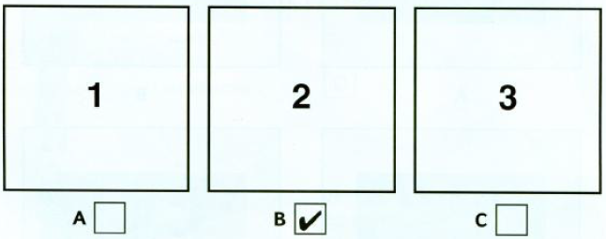
1. Where does Aunt Betty live in the summer?  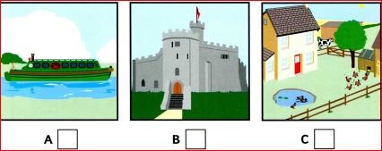 | TH
2.Where is Aunt Betty’s winter home?  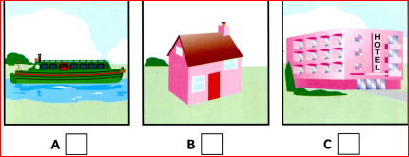 | TH
3. Where does Aunt Betty work in the winter?  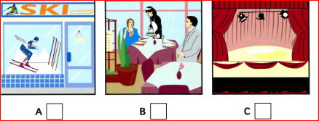 | NB
4. How often does Richard see Aunt Betty in the summer?  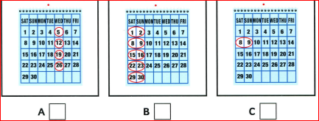 | TH
5..What do Richard and his sister do when they visitAunt Betty?  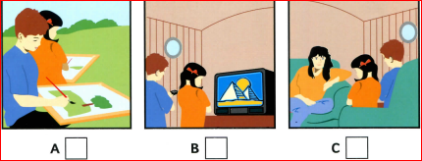 | NB
Part 3.Listen and match.( 0,5 points)
Day | Activities | Answers
0.Wednesday | A. went to the cinema( film a girl and helicopter) | (0)…C.
1.Thursday | B. had a picnic in the forest | (1)……. | TH
2. Saturday | C. went on holiday in the island by helicopter | (2)….… | VD
3. Monday | D. Flew kite and walked with the dog in the forest | (3)……. | VD
4. Tuesday | C. went to the beach and swam in the sea. | (4)……. | VD
5. Sunday | E. went to the beach and took photos of dog | (5)…….. | VD

SECTION B. LANGUAGE FOCUS – READING - WRITING (7,5points)
I. Phonetics (0,8pt):
*Find the word which has a different sound in the part underlined.
1. A. cow | B. now | C. how | D. show | (NB)
1 2. A. gather | B. monthly | C. father | D. brother | (NB)
*Find the word that has different stress pattern in each line.
3.A. kitchen | B. machine | C. houseboat | D. planet | (TH)
4.A.student | B. bedroom | C. village | D. enjoy | (NB)

II. Circle the best word/phrase (A, B, C or D) to complete the sentences below. (1,6pTs)
1. People in my village are very warm and …........…….(TH)
A.friendly B. exciting C. polluted D. noise
2.I like this gym. _______ equipment here is new and cool. (NB)
A. The | B. ø | C. An | D.A
3.Lake Baikal is the………………. freshwater lake in the world. (NB)
A. large | B. more large | C. larger | D. largest
4.The opposite of “dangerous” is ………………….(TH)
A. good | B. polluted | C. dirty | D. safe
5.My house is near ……. house, so I usually go there and play badminton with her. (NB)
A. hers | B. her | C. his | D. she
6………………eat too much salt. It’s not good for you. (NB)
- Do | - Don’t | - Please | - Can’t
7. We will have a ……………. to take care of our health. ( NB))
A. home robot B. doctor robot C. teaching robot D. worker robot
8. “I’ve just received a scholarship” “…………….!”(VD)
A. Really B. Thank you C. Congratulations D. Well

III. Give the correct form of the verbs in blankets: (0,6pt)
- Lan usually (play) ………………… volleyball every Sunday. (VD)
- They ( do) ……………………….their homework last night? (VD)
- If you walk to school, you (help)……………the environment. (VD)
- I’m thirsty. What about ( have)……………….. a glass of orange juice ? __(TH)

IV. IV. Read the following passage and put a word in the box in each of the numbered blanks: 1,2
well – known was and voted player in

Pele is widely regarded as the best football (1) …… NB ……………. of all time. He (2) …… VD ………. born on October 21st, 1940 in the countryside of Brazil. Pele’s father was a professional football player (3) ……NB………… taught him how to play at a very young age. Pele began his career at the age of 15. (4) … NB ……….. 1958, at the age of 17, he won his first World Cup. He won three World Cup and scored 1,281 goals in his 22-year career. He was (5) ……VD………. Football Player of the century. During his career, he became (6) … NB …………. around the world as The King of Football.
1 .............. 2 ................. 3 .................. 4 ....................5 .....................6 ……………..

V. Read the text carefully and answer the questions: (0,8 point)
In the future, we will live in amazing new houses. Our houses will use the sun or the wind to make electricity. We won’t have cookers, dishwashers or washing machines. We will have robots to cook our dinner and wash our clothes. We will have robots to look after our children, and to feed our cats and dogs.
We won’t use computers. We will have special remote control units. We can surf the Internet, send and receive e-mails and order food from the markets without getting out of bed.
We won’t have TVs or CD players because we will have watches that play music, take pictures and tell time. Our cars might not use gas. They might use energy from air, water or plants.
- Questions
- What will our houses use to make electricity in the future? TH
…………………………………………………………………………
- Will we have TVs or CD players? TH
…………………………………………………………………………
- Who will help us do the housework? NB
…………………………………………………………………………
- What kind of energy might our cars use? TH
…………………………………………………………………………

VI. Choose the underlined word or the phrase in each sentence below that is not correct. (0,5 point)
1. Last week, I and my brother come back to our home town. (NB)
A B C D
1. Mine home town is a very beautiful place. (NB)
A B C D
VI. Complete the second sentences so that it means the same as the sentence before. (1,0pt)
1. She is interested in watching television. (VD)
She likes …………………………………………………………………………
2. We will probably go to the moon for our summer holidays in 2050. (VD)
We might ……………………………………………………………….…….
3. We make the air dirty because we use the car all the time. (VDC)
If……………………………………………………………………………….
4 Nobody in my class is taller than Huy. (VD)
Huy is ……………………………………………………………………
VIII. Reorder the words and phrases to make sentences. (1,0point)
1. Lan/ shorter/ is/ Hoa. / than (TH)
………………………………………………………………………………………
2.How many/ are there/ on VTV3 / game shows / channel / tonight? (TH)
…………………..………………………………………………………………
3.visited/ We/ our grandparents/ last week. / in the countryside (VD)
…………………..………………………………………………………………
4.the most / Ha Long Bay/ beautiful/ in the world./ one of / natural wonder / is(VDC)
…………………..………………………………………………………………

THE END

ĐÁP ÁN VÀ HƯỚNG DẪN CHẤM ĐỀ KIỂM TRA KÌ II
MÔN: TIẾNG ANH – LỚP 6

SECTION A. LISTENING ( 2,5 points)
Part 1. Listen and write (1,0 points)
Mỗi câu đúng được 0,2 điểm
1.November | 2.William | 3.(their)school | 4. 11/eleven | 5.fishing
Part 2. Listen and tick. ( 1,0 points)
Mỗi câu đúng được 0,2 điểm
1.A | 2.B | 3.C | 4.C | 5.C
Part 3. Listen and match. (0,5 points)
Mỗi câu đúng được 0,1 điểm
1.B | 2.D | 3.A | 4.C | 5.E
SECTION B. LANGUAGE FOCUS – READING - WRITING (7,5points)
I. Phonetics (0,8pt):
Mỗi câu đúng được 0,2 điểm
1.D | 2.B | 3.B | 4.D
II. Circle the best word/phrase (A, B, C or D) to complete the sentences below. (1,6pts)
Mỗi câu đúng được 0,2 điểm
1.A | 2.A | 3.D | 4.B
5.B | 6. B | 7.B | 8.C

III. Give the correct form of the verbs in blankets: (0,6pt)
Mỗi câu đúng được 0,2 điểm
1.plays | 2. Did……do | 3. will help | 4.having
IV. Read the following passage and put a word in the box in each of the numbered blanks :(1,2pt)
Mỗi câu đúng được 0,2 điểm

1. player | 2. was | 3. and | 4.in | 5. voted | 6. Well-known

V. Read the text carefully and answer the questions: (1point)
Mỗi câu đúng được 0,2 điểm
1. Our houses will use the sun or the wind to make electricity in the future.
2. No, we won’t.
3. Robots will help us do the housework.
4. Our cars/They might use energy from air, water or plants.
VI. Choose the underlined word or the phrase in each sentence below that is not correct. (0,5 point)
Mỗi câu đúng được 0,25 điểm
1.B | 2.A
VI. Complete the second sentences so that it means the same as the sentence before. (1,0pt)
Mỗi câu đúng được 0,25 điểm

1. She likes watching television.
2. We might go to the moon for our summer holidays in 2050
3. If we don’t use the car all the time, we will make the air dirty
4. Huy is the tallest ( boy) in my class
VIII. Reorder the words and phrases to make sentences. (1,0point)
Mỗi câu đúng được 0,25 điểm
- Lan is shorter than Hoa
- 2.How many game shows are there on VTV3 channel tonight?
- We visited our grandparents in the countryside last week.
- Ha Long Bay is one of the most beautiful natural wonder in the world

THE END

