KIỂM TRA GIỮA KỲ I – NĂM HỌC 2022 – 2023 (ĐỀ 2)
MÔN TIẾNG ANH- LỚP 9

A- LISTENING: 2PTS
I. Listen and tick the box. (1.0pt)

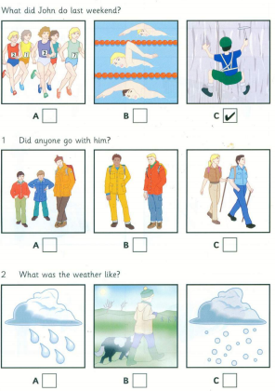 | 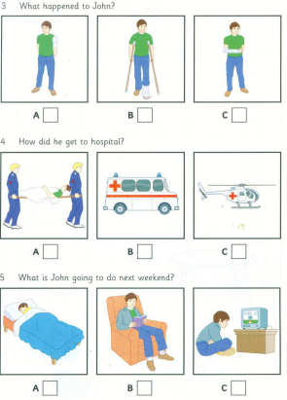

II. Listen and write the words in the blank numbered. There is one example(1.0pt)
New street school library
Full name:  Age:  Teacher’s name:  Favorite books :  Hobbies:  How many books: | Sarah Fanner  (1)_____________________________  (2) Mrs ________________________  (3)_____________________________  (4)_____________________________  (5)_____________________________
B.GRAMMAR – VOCABULARY – LANGUAGE FUNCTION: 2PTS
Choose the best answer (circle A, B, or C) to complete the sentence. (2.0pts)
1. He feels ________ after the exam because he did the test very well.
A. stressful B. delighted C. nervous
2. ________, I’d buy an English – Vietnamese dictionary.
A. If I have money B. If I had your shoes C. If I were in your shoes
3. City life not only offers young people with lots of opportunities, but it has lots of ________as well.
A. variety B. advantages C. drawbacks
4. What is the point of trying to stay here when you don’t have a job? You have been ______ for two years!
A. uncomfortable B. unemployed C. unhappy
5. Many teens try to work hard to meet parents’ ______.
A. hope B. expectation C. belief
6. Transportation systems in big cities are often ___________ those in the countryside.
A. more reliable B. more reliably than C. more reliable than
7. Many students do not know ________to get cognitive skills.
A. how B. what C. how much
8. Man: Congratulations! Boy: _____________
A. I’m sorry. B. Thank you. C. What a pity!
9. They have to ________the factory because of the economic problem.
A. close down B. turn down C. pass down
10. If you don’t know the meaning of this word, ________ in the dictionary!
A. look for B. look after C. look up
C. READING
I. Which notice (A - H) says this (1 - 5)? For questions 1 - 5, write the correct letter A - H next to the number. (1.5pts)
1 - You get more for your money.  2 - You cannot go here on Sunday.  3 - If you come early, you can sit here.  4 - You won't need to pay for small kids.  5 - You will need to have cash here. | 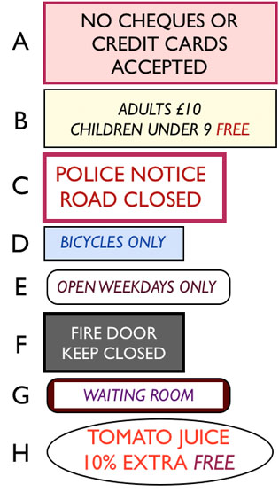

II. Read the passage and answer the questions that follow. (1.5 point)
Sydney is Autralia’s most exciting city. The history of Australia begins in this city. In 1788, Captain Arthur Phillips arrived in Sydney with 11 ships and 1624 passengers from Britain (including 770 prisioners). Today there are about 4 million people in Sydney. It is the biggest city in Australia, the busiest port in the South Pacific and one of the most beautiful cities in the world. There are over twenty excellent beaches close to Sydney and its warm summer climate and cool winter have made it a favorite city for immigrants from overseas. There are three things that make Sydney famous: its beautiful harbor, the Sydney Harbor Bridge, which was built in 1932 and the Sydney Opera House, which was opened in 1973.
1. Which is the most exciting city in Australia?
A. Sydney | B. Sydney Harbor Bridge | C. Sedney Opera House
2. How many passengers from Britain arrived in Sydney in 1788?
A. 1604 | B. 1642 | C. 1624
3. What is the population of Sydney today?
A. 4 billion | B. 4 million | C. 4 thousand
4. Sydney is one of .........cities in the world
A. the most beautiful | B. the biggest | C. All are correct
5. When was the Sydney Harbor Bridge built?
A. 1973 | B. 1923 | C. 1932
D. WRITING ( 3PTS).
I. Change the sentences into direct or indirect speech. (1,5pts)
1. William said, “I am not visiting her again.”
-> William said ………………………………………………………………
2. “When can I take this English test? ”. Phuc asked
-> Phuc wanted to know …………………………………………………
3. We are expecting to see you again with pleasure. (looking )
->……………………………………………………………………………
4. We arranged to meet each other , but she never arrived. (turned)
->…………………………………………………………………
5. She was very tired, but she tried to finish her homework. (although)
->……………………………………………………………
II. Living in the city has a lot of advantages. Write a short paragraph of 80-100 words to talk about this. Using the outline below (1.5pts). OUTLINE
Topic sentence : Living in the city has a lot of advantages.
Firstly, …………………….
Secondly, …………………..
Thirdly,……………………..
Finally ,……………………..
Conclusion : Therefore / In short/ In conclusion /….
…………………………………………………………………………………………………
…………………………………………………………………………………………………
…………………………………………………………………………………………………
…………………………………………………………………………………………………
…………………………………………………………………………………………………
…………………………………………………………………………………………………
ĐÁP ÁN VÀ HƯỚNG DẪN CHẤM

Listening  (2pts) | I- (1,0pts)  1- C 2- B 3- A 4- C 5- B  II- (1,0pts)  1- 8 2- Mrs Drummond 3- Animal stories  4- riding (horses) 5- 5 | 0.2 x 5 = 1,0  0.2 x 5 = 1,0
Language focus  (2ps) | 1. B 2. C 3. C 4. B 5. B  6. C 7. A 8. B 9. A 10. C | 0.2 x 10 =2,0
Reading  (3pts) | I. 1 – H 2 – F 3 – E 4 – A 5 – G  II. 1. A 2. B 3. B 4. C 5. C | 0.3 x 5 =1,5  0.3x 5 = 1,5
Writing  (3pts) | I. 1. William said he was not visiting her again.  2. Phuc wanted to know when he could take in that English test  3. We are looking forward to seeing you again.  4. We arranged to meet eachother , but she never turned up.  5. Although She was very tired, she tried to finish her homework.  II.  Ss’ answers. - Fulfillment  - No grammar or spelling mistakes | 0.3 x 5= 1,5  1,5

