UNIT 5 VIETNAMESE FOOD
AND DRINK

A. PHONETICS

I. Look at the pictures and complete the words. Then put them in the correct column

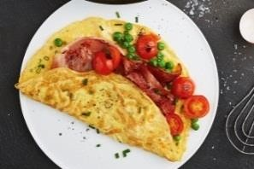
1. o e e t 2. f

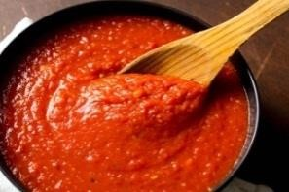
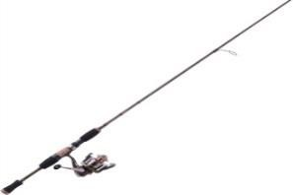
3. s u e 4. r

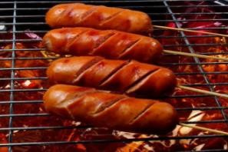
5. s s g
7. 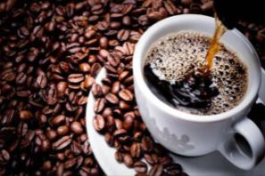 c ff
9. 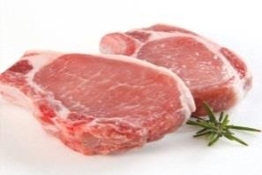 p r
11. 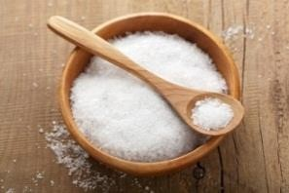 s l
13. 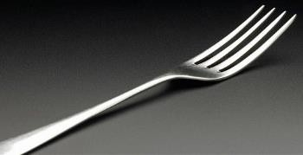 f r
6. w t

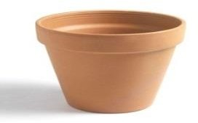
8. p
10. 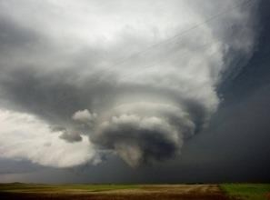 s o m
12. 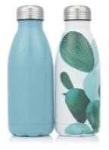 b t l
14. h r e

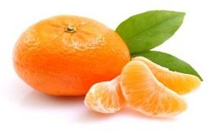
15. r n e 16. d gh er

/ɒ/ | /ɔː/

II. Choose the word that has the underlined part pronounced differently.

1. a. tofu | b. opera | c. hot | d. bottle
2. a. taught | b. water | c. sandwich | d. author
3. a. apple | b. pancake | c. snack | d. salt
4. a. sauce | b. saw | c. bought | d. yoghurt
5. a. torch | b. pot | c. omelette | d. rock
B. VOCABULARY AND GRAMMAR

I. Match the food or spice with its definition.

1. omelette
2. sausage
3. pepper
4. turmeric

5. sauce
6. noodles
7. tofu
8. spring rolls
a.
a thick liquid eaten with food to add flavour
b. a food in the form of long, thin strips cooked in soup
c. a dish made by mixing eggs together and frying them
d. a food consisting of a small roll of pastry filled with meat and vegetables, and fried
e. a small tube of skin filled with a mixture of meat, spices etc,
f. a soft white food made from soya beans
g. a yellow powder made from the root of an Asian plant
h. a grey or white powder used to give a spicy, hot taste to food

II. Complete each sentence with the word in part I. Use the picture as a cue.
1. Jane eats quite often because it is healthy.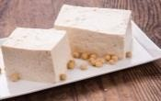
2. Would you like bacon or ? 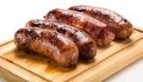
3. Add some to give the chicken a yellow colour. 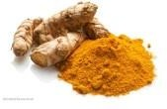
4. To make an _ you must first beat the eggs. 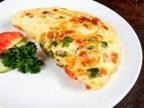
5. Do you want to eat or rice? 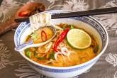
6. Don‟t put so much in the soup. 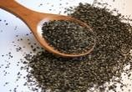

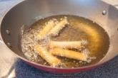
7. Heat the oil, then deep-fry the .

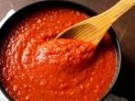
8. I made some spaghetti for dinner.

III. Underline the correct words.
1. She bought a loaf/ bowl/ bar of bread so we can make sandwiches.
2. We‟ve already eaten a tube/ packet/ slice of biscuits!
3. Would you like a bowl/piece/glass of lemonade?
4. There is a piece/ carton/ kilo of milk in the fridge.
5. Could you cut me a smaller slice/ spoon/ bunch of ham?
6. You can have a loaf/ piece/ pot of cake after you‟ve eaten your vegetables!
7. See round the grocer‟s for a bottle/ tin/ tube of sardines.
8. She ate a glass/ slice/ bowl of noodles yesterday morning.
9. Anna always eats a slice/ bar/ loaf of chocolate on her way to school.
10. He got a can/ piece/ carton of Coke from the fridge because he was thirsty.

IV. Complete the instructions to make a basic French omelette with the verbs in the box.
server beat fold heat pour place
(1) eggs, water, salt and pepper in small bowl until blended. (2)
butter in nonstick omelet pan. (3) in egg mixture. Mixture should set immediately at edges. When top surface of eggs is thickened and no visible liquid egg remains, (4)
filling, such as shredded cheese, finely chopped ham on one side of the omelet. (5)
omelet in half with turner. With a quick flip of the wrist, turn pan and invert omelet onto plate. (6) immediately.

V. Write C for countableand U for uncountable.

1. beef |  | 7. spinach |  | 13. turmeric
2. apple |  | 8. egg |  | 14. pancake
3. bread |  | 9. butter |  | 15. vegetable
4. biscuit |  | 10. lemonade |  | 16. coffee
5. rice |  | 11. sandwich |  | 17. sugar
6. spring roll |  | 12. ham |  | 18. orange
VI. Fill in the blanks with a, an, some or any.
1. Have you got _ potatoes?
2. I‟d like bread, and piece of cheese, please.
3. For breakfast, I have ham sandwich and orange juice.
4. Here are cereals, but there isn‟t milk.
5. Would you like beer or would you prefer bottle of Coke?
6. Is there rice left? ~ I‟m afraid there isn‟t rice left, but youcan have
noodles instead.
7. There aren‟t bananas, but there is apple and grapes.
8. I want jam and butter for my toast.
9. Can I have sausages and omelette with fries on the side, please?
10. My father always has biscuit and cup of tea at bedtime.
VII. Complete the sentences with How much or How many.
1. grams of sugar per day should we consume?
2. bread do we need?
3. coffee do you drink in a day?
4. steaks do you want?
5. meat do we need for the barbecue tonight?
6. bottles of orange juice have you had today?
7. hamburgers did he eat?
8. cream would you like in your coffee?
9. potatoes are there in the basket?
10. rice can I put in the soup?
VIII. Make questions with How much or How many.
1. cups of butter/ we/ need/ for this recipe

2. milk/ you/ like/ in your tea

3. grapes/ there/ in the fridge

4. cakes/ she/ make/ for the party last night

5. pork/ your mother/ want/ for the barbecue

6. cat food/ you/ buy /at the supermarket/ yesterday

7. exams/ they/ have/ so far

8. tea/there/ in the teapot

IX. Read the dialogue and circle the correct words.
Lucy: How about making (1) a/ an apple pie?
Alan: Great idea! Have we got (2) some / any apples?
Lucy: Yes, there are (3) some / any in the bowl. (4) How much / How many do we need? Alan: A lot, about a (5) kilo / litre.
Lucy: We haven‟t got enough. We can buy (6) some / any in the corner shop.
Alan: And we need (7) some / any flour, too. Look at the recipe. (8) How much / manyflour do we need?
Lucy: About half a pound.
Alan: And (9) how much / how many eggs do we need?
Sue: Four. And we also need (10) some / any butter and (11) some / any sugar. Oh, we haven‟t got (12) some / any butter.
Andy: We can buy (13) a / some bar of butter in the shop, too.

X. Fill in each blank with a suitable preposition.
1. Is there any milk the fridge?
2. There was a lot of food left over the party.
3. You can warm _ the leftovers in the microwave.
4. Beat the eggs together salt, pepper and cold water.
5. Serve the pancakes some vegetables or fruits.
6. Pho is a special kind Vietnamese soup.
7. Pour about ¼ cup of mixture the pan at a time.
8. The broth for pho bo is made stewing cow bones a long time.
9. Simmer the sauce a low heat.
10. Cut the meat small pieces.
C. SPEAKING

I. Complete the dialogues with the phrases or sentences in the box.
A glass of orange Juice, please.
I prefer something sweet. Four cartons, please.
Twice a month.
I Just have some cereal each morning
I love Pho.
Four or five small meals. Yes, two slices, please.
1. A: What kind of Vietnamese food do you like?
B:
2. A: What would you like to drink?
B:
3. A: What is your favourite taste?
B:
4. A: How much milk do you need?
B:
5. A: How often do you drink milk tea?
B:
6. A: Would you like some cheese?
B:
7. A: What are you going to have for breakfast?
B: 8. A: How many meals do you usually eat every day?
B:

II. Complete the dialogue with the appropriate phrases (A - F).

- Then add some yeast and a pinch of salt to the mixture. Mix with a whisk.
- My pleasure. Enjoy your pancakes!
- Just cook until golden then serve with some fruit or vegetables.
- Sure. All you need is some butter, 1/2 a litter of milk, 250 grams of flour and 4 eggs.
- Heat some butter in a frying pan and pour about 1/4 cup of the mixture into the pan at a time.
F.First, beat 4 eggs together with flour and milk.
Anna: Can you tell me how to make pancakes, please?
Beck: (1) Anna: What do I have to do?
Beck: (2) Anna: What do I do after that?
Beck: (3) Anna: What‟s next?
Beck: (4) Anna: And then?
Beck: (5) Anna: Oh... that sounds simple! Thanks a lot.
Beck: (6)
D. READING

I. Fill in each blank with a word from the box.
basic stewing pot vary most even broth rice

Pho is one of the (1)

Vietnamese noodle soup consisting of (2)
popular Vietnamese dishes. What is pho? Pho is a
, rice noodles, herbs and meat.

There are two (3) types of pho and that is Pho Bo (beef noodle soup) and Pho Ga (chicken noodle soup). Pho Bo is beef broth that is made by stewing cow bones in a large (4)
for quite a long time. Pho Ga is very similar to Pho Bo. Instead of beef broth, chicken broth is made by (5) chicken bones. The noodle itself is made from varieties of (6) . The ingredients and toppings may (7) a slight bit in the North and the South.
Pho is normally eaten for breakfast, but many of people eat at lunch, or (8) dinner.

II. Read the text carefully then decide whether the following statements are true (T) or false (F).
Once being a basic food of farmers and poor families in Vietnam, com tam or broken rice is now a favourite dish of most Vietnamese. It is said that the best broken rice can be found in Saigon. When you come to Saigon, you should try this dish at least one time and you will not regret it.
Com tam literally means broken rice. Broken rice originally consisted of grains which were broken during the harvesting and cleaning of rice. In the past, as most people preferred to eat the long, whole grain rice, broken rice grains were difficult to sell and usually eaten by the Vietnamese working class because of the cheap price. Nowadays, often favored over long grain rice for its unique flavour and texture, broken rice is one of the best-loved fares in Vietnam.
Local broken rice eateries can practically be found on every street in Saigon. A broken rice dish is served with many beautiful colours from grilled pork chop with multi-flavour to steamed egg, shredded pork skin, pickles, vegetables such as tomatoes, cucumbers ... and especially sweet fish sauce that is the spirit of the dish.
1. Today, com tamis only eaten by poor Vietnamese.
2. Com tamis made from broken rice grains.
3. In the past, most people didn‟t eat broken rice grains because they were cheap.
4. It is difficult to find a place to eat com tam in Saigon.
5. The most important part of com tamis sweet fish sauce.
6. Com tamis now a favourite dish of Vietnamese people, especially Saigonese.
E. WRITING

I. Arrange the words to make sentences.
1. kilos/how many/would/potatoes/of/like/you/?

2. but/went/I/fish/ I/ fishing/ catch/didn‟t/any/.

3. 15/ cook/for/chicken/you/over/ the/low/minutes/heat/it/before/ serve/.

4. broken/tell/you/can/how/me/to/rice/cook/?

5. three/in/fridge/are/there/milk/the/cartons/of/.

6. has/but/egg/bread/got/he/an/hasn‟t/he/any/got/.

7. electric cooker/how much/in/rice/left/the/is/?

8. Vietnam/most/Pho/of/the/popular/is/one/dishes/in/.

II. Write the second sentence so that it has the same meaning as the first one.
1. I‟ve never seen such a boring movie.
→ It is
2. There are a few eggs in the fridge.
→ There are not
3. They have lived there for two years.
→ They started
4. This is the first time I have drunk cocktail.
→ I have never
5. This exercise is easier than the last one.
→ This exercise is not
6. I‟m bored of playing computer games.
→ I find
7. The new building is as high as the old one.
→ The new building is the same
8. She had no eggs, so she didn‟t make an omelette.
→ She didn‟t have

TEST FOR UNIT 5

I. Choose the word whose underlined part is pronounced differently from the others.
1. a. bread b. beef c. meat d. tea
2. a. audience b. sauce c. sausage d. taught
3. a. eggs b. cups c. cartons d. noodles
4. a. soup b. salt c. sauce d. sugar
5. a. fridge b. rice c. spinach d. milk

II. Choose the odd one out.
1. a. juice b. sandwich c. lemonade d. milk
2. a. sweet b. sour c. salty d. sauce
3. a. egg b. pork c. beef d. ham
4. a. cheese b. salt c. orange d. bread
5. a. bowl b. glass c. plate d. fork

III. Choose the best answer a, b, c, or d to complete the sentence.
1. Pho is always served fresh herbs, bean sprouts, sliced-up chiles, and lime.
a. for b. with c. in d. on
2. This cake is made fresh butter and eggs.
a. in b. of c. by d. from
3. You don‟t need to take _ food on the trip.
a. a b. some c. any d. the
4. We need a of bread to make the sandwiches for everyone.
a. carton b. bar c. loaf d. tube
5. There was some ham from lunch.
a. leave b. leaving c. to leave d. left
6. My lemonade is a bit . Can you give me some sugar, please?
a. sour b. sweet c. spicy d. salty
7. Would you like milk in your coffee?
a. any b. some c. a d. a few
8. How cheese do we need to make a cheese cake? ~ About 250 grams.
a. few b. many c. much d. little
9. Flour is the main in cakes.
a. recipe b. dish c. formulary d. ingredient
10. Alan:
Huan: Pho, bun cha, bun bo, banh mi, com tam, etc. a.What Vietnamese food should I try?
b.What‟s your favourite drink?
c.How do you cook Vietnamese food?
d.How much food do you like?

IV. Write the correct tense or form of the verbs in brackets.
1. My house is very dirty. I (clean) it tomorrow.
2. This coffee (taste) terrible, but the biscuits (be) great.
3. Pho (become) more and more popular in Saigon since 1954.
4. Last year we (go) on a school trip to Scotland.
5. At the moment Joana (learn) to cook some Vietnamese dishes.
6. I‟m very sorry Dr. Jones (not be) back in the clinic until 2pm.
7. The chicken meat served with pho ga (cut) into thin slices.
8. My father (eat) pho almost every morning at the restaurant nearby.
9. The broth is made by (stew) cow bones for a long time.
10. What is there (drink), Mike?

V. Supply the correct form of the words in brackets.
1. The soup had a very taste. (salt)
2. She covered the cake with a of sugar and whites of eggs. (mix)
3. Most children enjoy eating chicken and French fries. (fry)
4. The pineapple was sweet and . (juice)
5. Meats and fish are used in all Vietnamese cooking. (common)
6. The chicken meat is and cut into thin slices. (bone)
7. It took about 30 minutes of and 40 minutes of baking. (prepare)
8. The sauce itself was and slightly sweet. (fragrance)

VI. There is one mistake in each sentence. Underline and correct the mistake.
1. How many orange juice have you had today?

2. Are there some eggs in the fridge?
3. Would you like a cheese with your pasta?
4. Salt is one of important ingredient for almost dishes.
5. Can you buy some breads on your way home?
6. What do you usually have in breakfast?
7. Vietnamese eat more instant noodles to Japanese.
8. How many glass of water should you drink per day?

VII. Match the questions with the answers.

1. Are you ready to order?
2. How much flour do we need?
3. What is there to drink?
4. What Vietnamese food can you cook?
5. How many slices of ham do you want?
6. How does this garlic soup taste?
7. Would you like another bowl of rice?
8. Do you want something to drink?

VIII. Choose the word which best fits each gap.
a.Beer, orange juice and mineral water. b.Very good.
c.Two or three.
d.No, thanks. I‟m full.
e.Yes. I‟d like chicken with rice, please. f.Just a bottle of mineral water, please. g.Bun bo and mien ga.
h. 250 grams.

Pho might be Vietnam‟s (1) famous dish, butbun cha is the top choice when it comes to lunchtime in Hanoi. It doesn‟t matter if you eat bun cha in a restaurant or a small cart on the street, you will be (2) by a plate of vermicelli (bun), a bowl of broth with grilled pork and a (3) of fresh herbs. The vermicelli and fresh herbs are pretty common in a Vietnamese restaurant. The broth and the pork are the ones that make this dish (4) . Bun cha sets often come with the delicious nemcua be– friedcrab spring (5) . Still not convinced? It‟s what Obama ate during his night (6) with Bourdain.

1. a. most | b. the most | c. best | d. the best
2. a. cooked | b. made | c. served | d. tried
3. a. bottle | b. pot | c. bar | d. basket
4. a. simple | b. comfort | c. specially | d. unique
5. a. pieces | b. rolls | c. halves | d. slices
6. a. out | b. in | c. towards | d. along

IX. Read the text carefully then choose the correct answers.
Vietnamese food culture varies by regions from the north to the south. In Northern Vietnam, food is characterized by light and balanced. Northern Vietnam is seen to be the cradle of Vietnamese cuisine with many notable dishes like Pho, Bun Rieu, Bun Thang, Bun Cha, BanhCuon, etc. Then, food culture in Northern Vietnam became popular in Central and Southern Vietnam with suitable flavors in each regions.
The regional cuisine of Central Vietnam is famous for its spicy food. Hue cuisine is typical Central Vietnam‟s food culture. Food in the region is often used with chili peppers and shrimp sauces, namely, Bun Bo Hue, BanhKhoai, BanhBeo, etc.
In Southern Vietnam, the warm weather and fertile soil create an ideal condition for planting a variety of fruit, vegetables and livestock. Thus, food in the region is often added with garlic,
shallots and fresh herbs. Particularly, Southerners are favored of sugar; they add sugar in almost dishes. Some signature dishes from Southern Vietnam include BanhKhot and Bun Mam.
1. It is considered that Vietnamese cuisine . a.originated from the North
b.became more and more popular
c.always combines taste and colour
d.can be found only in Northern Vietnam
2. What are the features of Northern Vietnamese food?
a. It‟s delicious and healthy. b. It‟s sweet and sour.
c.It‟s light and balanced. d. It‟s a bit fatty and salty.
3. Hue cuisine is notable for its .
a. colorful food b. spicy taste c. bitter taste d. light flavor
4. In Southern Vietnam, .
a.the warm weather makes it hard to plant fruit and vegetables
b.fresh herbs are always used in cooking
c.people love sweet food
d.sugar is often added to dishes
5. Which of the followings is NOT true? a.Food in Vietnam changes region to region.
b.Southerners do not like northern food due to its light flavor.
c.Chill peppers and shrimp sauces are among the frequently used ingredients.
d.Bun Bo Hue is a typical dish of the Central Vietnam cuisine.

X. Make questions for the underlined parts.
1. She needs twelve eggs to make two cakes.

2. They drank a lot of wine at the party last night.

3. I often drink coffee in the morning.

4. Beef noodle soup is my favourite food.

5. My lemonade tastes a bit sour.

6. No, there isn‟t any milk in the fridge.

7. No, thanks. I love cookies, but I‟m full.

8. The beef broth is made by stewing cow bones.

ĐÁP ÁN

 |  | UNIT 5
A. PHONETICS
I. 1. omelette | 2. fox | 3. sauce | 4. rod | 5. sausage
6. water | 7. coffee | 8. pot | 9. pork | 10. storm
11. salt  16. daughter | 12. bottle | 13. fork | 14. horse | 15. orange

/ɒ/ | /ɔː/
omelette, fox, rod, sausage, coffee, pot, bottle, orange | sauce, water, pork, storm, salt, fork, horse, daughter
II. 1. a 2. c 3. d 4. d 5. a
B. VOCABULARY AND GRAMMAR
I. 1. c 2. e 3. h 4. g 5. a 6. b 7. f 8. d
II. 1. tofu 2.sausage 3. turmeric 4. omelette
5. noodles 6. pepper 7. spring rolls 8. sauce
III.1. loaf 2. packet 3. glass 4. carton
5. slice 6. piece 7. tin 8. bowl
9. bar 10. can
IV. 1. Beat 2. Heat 3. Pour 4. place 5. Fold 6. Serve
V. 1. U 2. C 3. U 4. C 5. U 6. C 7. U 8. C 9. U 10. U
11. C 12. U 13. U 14. C 15. C 16. U 17. U 18. C

VI. 1. any  5. some - a | 2. some - a  6. any - any - some | 3. a - some  7. any - an - some | 4. some - any  8. some - some
9. some - an | 10. a - a
VII.1. How many | 2. How much | 3. How much | 4. How many
5. How much | 6. How many | 7. How many | 8. How much
9. How many | 10. How much
VIII.1. How many cups of butter do we need for this recipe? 2.How much milk would you like in your tea?
3. How many grapes are there in the fridge?
4. How many cakes did she make for the party last night? 5.How much pork does your mother want for the barbecue?
6.How much cat food did you buy at the supermarket yesterday? 7.How many exams have they had so far?
8.How much tea is there in the teapot?

IX. 1. an  5. kilo |  | 2. any  6. some |  | 3. some  7. some |  | 4. How many  8. How much
9.how many |  | 10. some |  | 11. some |  | 12. any |  | 13. a
X. 1. in | 2.from |  | 3. up |  | 4. with
5. with | 6. of |  | 7. into |  | 8. by - for
9. on/over | 10.into

C. SPEAKING
I. 1. I love pho. 2.A glass of orange juice, please.
3. I prefer something sweet. 4.Four cartons, please.
5. Twice a month. 6.Yes, two slices, please.
7. I just have some cereal each morning. 8. Four or five small meals.
II. 1. D 2. F 3. A 4. E 5. C 6. B

D. READING
I. 1. most  5. stewing  II. 1. F 2. T | 2. broth  6. rice  3. F 4. F | 5. T | 3. basic  7. vary  6. T | 4. pot  8. even
E. WRITING
I. 1.How many kilos of potatoes would you like?
2. I went fishing but I didn‟t catch any fish.
3. Cook the chicken over the low heat for 15 minutes before you serve it. 4.Can you tell me how to cook broken rice?
5.There are three cartons of milk in the fridge.
6.He has got an egg but he hasn‟t got any bread.
7.How much rice is left in the electric cooker?
8.Pho is one of the most popular dishes in Vietnam.
II. 1.It is the most boring movie I‟ve ever seen.
2.There are not many eggs in the fridge.
3.They started living there two years ago.
4. I have never drunk cocktail before.
5. This exercise is not as hard/difficult as the last one.
6. I find playing computer games boring.
7. The new building is the same height as the old one.
8. She didn‟t have any eggs, so she didn‟t make an omelette.
TEST FOR UNIT 5
I. 1. a 2. c 3. b 4. d 5. b
II. 1. b 2. d 3. a 4. c 5. d
III.1. b 2. d 3. c 4. c 5. d 6. a 7. b 8. c 9. d 10. a
IV. 1. am going to clean 2.tastes – are 3.has become 4.went
5. is learning 6.won‟t be
7.is cut 8.eats
9.stewing |  |  | 10.to drink
V. 1. salty |  |  | 2.mixture
3.fried |  |  | 4.juicy
5. commonly |  |  | 6.boneless
7.preparation |  |  | 8.fragrant
VI. 1. many → much |  |  | 5.breads → bread
2.some → any |  |  | 6.in → for
3.a → some |  |  | 7.to→ than
4.ingredient → ingredients |  |  | 8.glass→ glasses
VII. 1. e 2. h 3. a | 4. g | 5. c | 6. b 7. d 8. f
VIII. 1. a 2. c 3. d | 4. d | 5. b | 6. a
IX. 1. a 2. c 3. b | 4. d | 5. b
X. 1. How many eggs does she need to make two cakes?
2.How much wine did they drink at the party last night?
3. When do you often drink coffee?
4.What is your favourite food?
5.How does your lemonade taste?
6.Is there any milk in the fridge?
7.Would you like some cookies?
8.How is the beef broth made?

